Object oriented Programming using java

Features of java

* Simple : because it doesnot have * operator
* Platform independent: the code written in windows machine can run on linux or Mac machine also.
* Machine independent-🡪 it is underlying h/w independent
* High level language🡪 in java we cannot access low level memory by address in the program.
* Multithreading is possible
* Networking is possible
* Data base connectivity is possible
* GUI programming is possible
* Garbage collector facility is available-🡪 so no memory leakage problem.
* Compiler and Interpreter
* Object oriented.

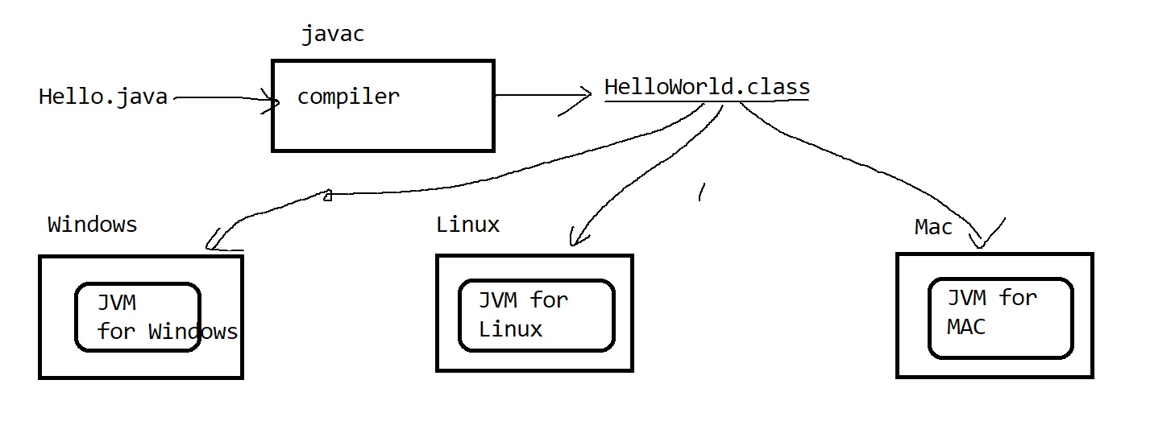

JVM

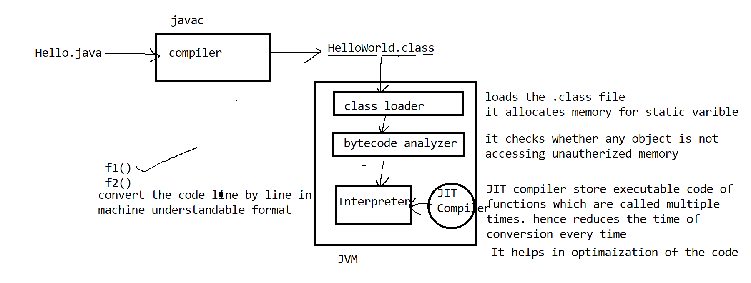

System, Integer, String all these are classes in java.lang library, hence no import is required

To store all .class files in separate folder by name bin

C:\javademos> javac -d bin HelloWorld.java

To run the file

C:\javademos> java -classpath .\bin HelloWorld

To avoid adding classpath for every execution, we may set classpath

C:\javademos>set classpath=.\bin; C:\Program Files\Java\jdk1.8.0_162\lib

Basic data types

byte > short > int > long >float > double

basic operators --🡪 +, -, /, %, *, ++, --

Relational operators -🡪 > , <, >=, <=, == , !=

Logical operators-🡪 &&, ||, !

Bitwise operators🡪 >>, <<, &, |, ~

